Image Analysis using Kibana Results:

Duration vs How he felt afterwards

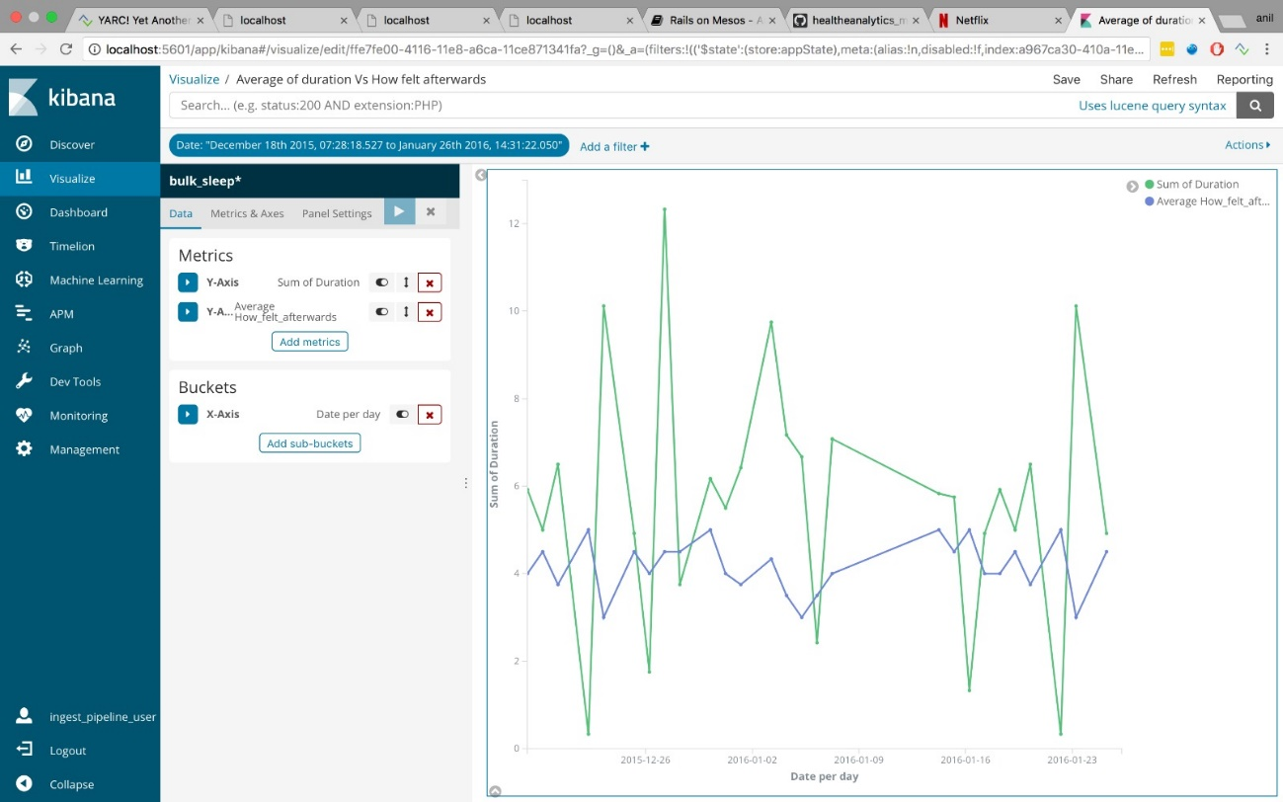

Analysis

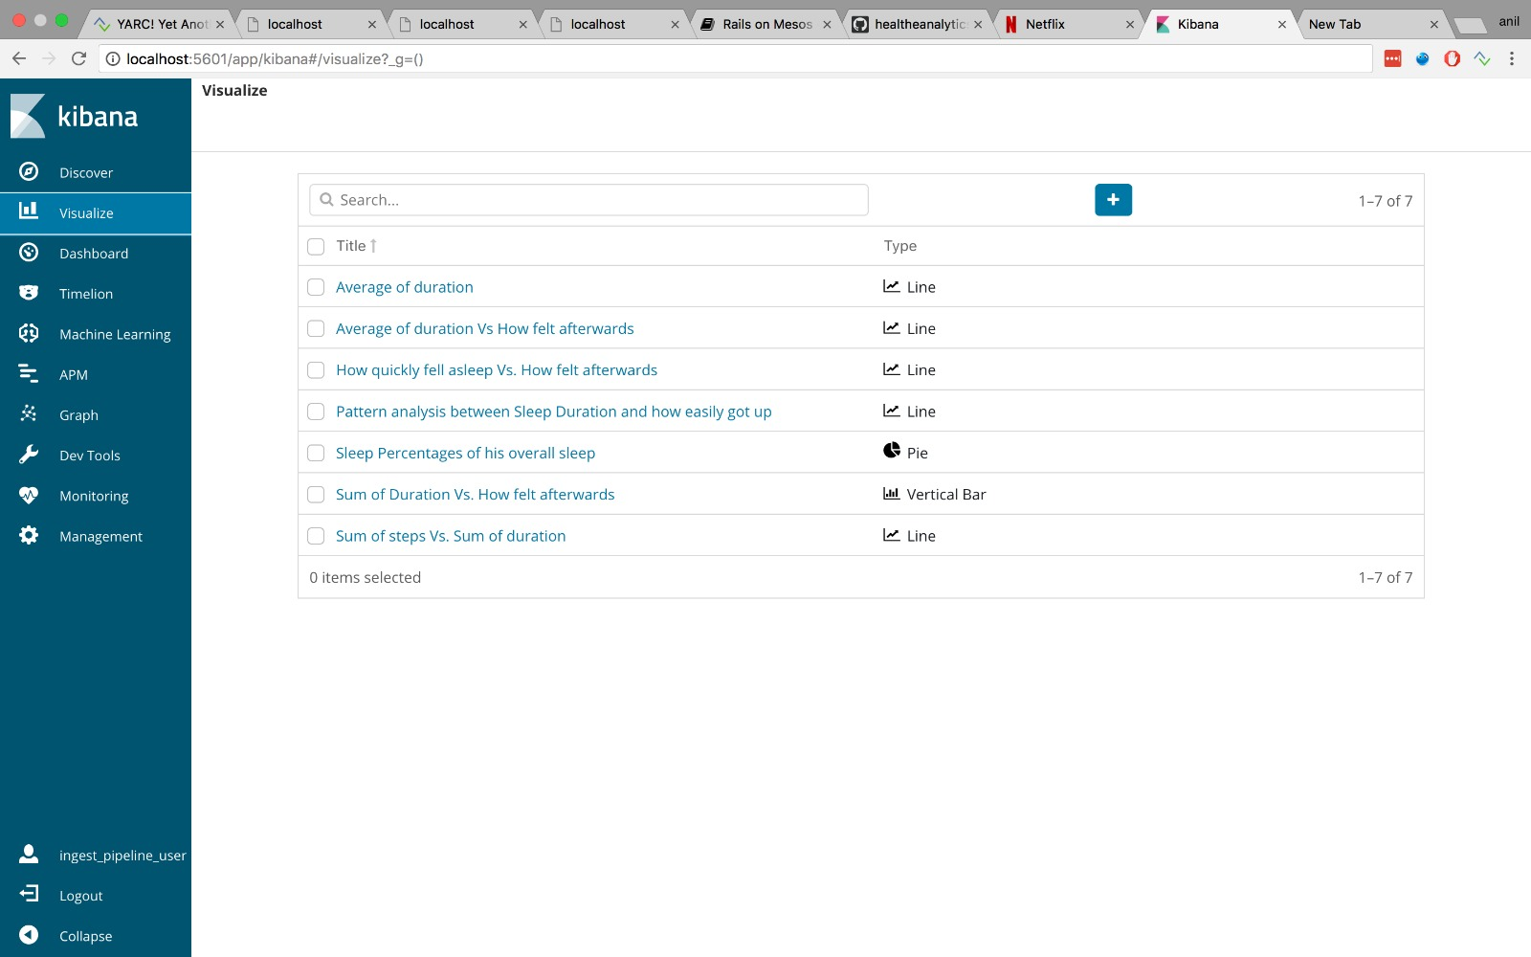

Dashboard Containing all the Analysis Graphs:

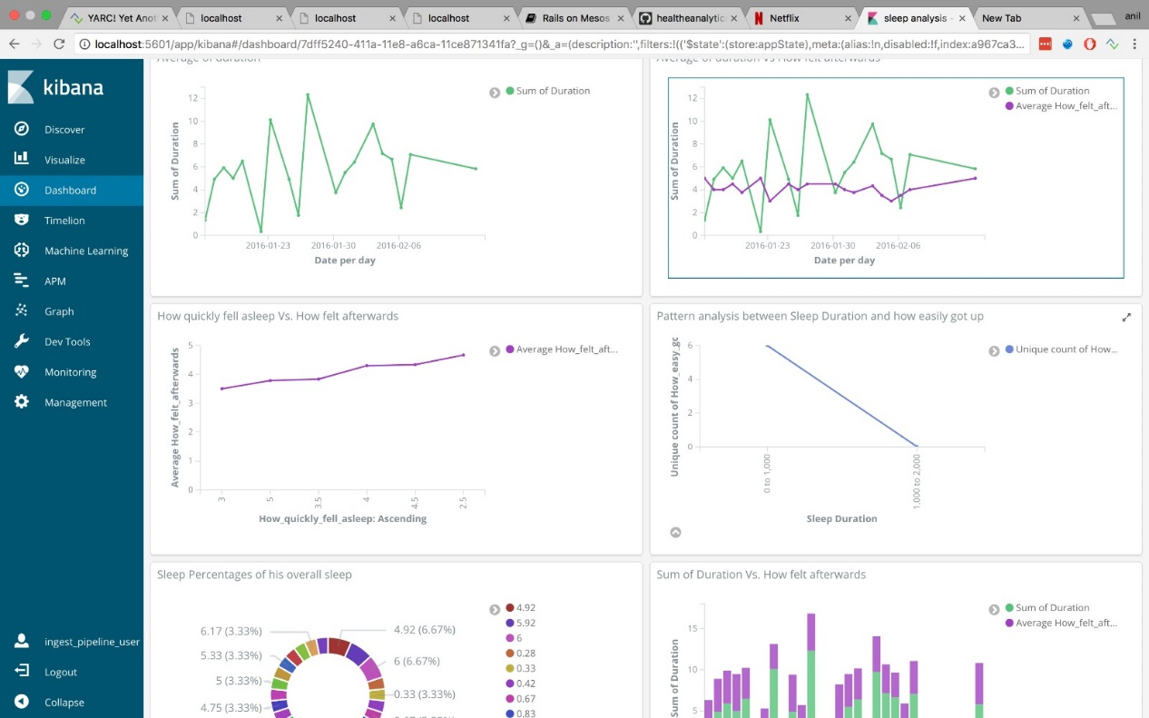

Future Prediction Using Machine Learning and training AI model:

